Q1 .

Client:

import socket

s=socket.socket()

s.connect(('127.0.0.1',7777))

data=s.recv(1024)

print(data.decode())

s.close()

Server :

import time

import socket

ss=socket.socket()

ss.bind(("",7777))

ss.listen()

client,addr=ss.accept()

currenttime=time.ctime(time.time())+'\r\n'

client.send(currenttime.encode())

Output :

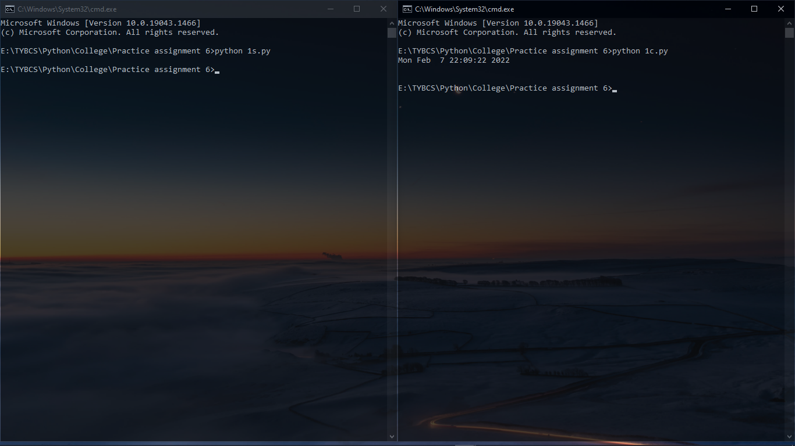

Q2 .

Client:

import socket

from datetime import datetime

usr=input("Enter name : ")

s=socket.socket()

s.connect(('127.0.0.1',6666))

data=s.recv(1024)

datestr=data.decode()

datetime_obj=datetime.strptime(datestr,"%d%b%Y%H%M%S")

time=datetime_obj.time()

h=time.hour

if h>=0 and h<12:

    print("Good morning, ",usr)

elif h>=12 and h<16:

    print("Good afternoon, ",usr)

elif h>=16 and h<19:

    print("Good evening, ",usr)

elif h>=19 and h<24:

    print("Good night, ",usr)

s.close()

Server :

import socket

from datetime import datetime

currenttime=datetime.now()

timestring=currenttime.strftime("%d%b%Y%H%M%S")

ss=socket.socket()

ss.bind(('',6666))

ss.listen()

client,addr=ss.accept()

client.send(timestring.encode())

client.close()

Output :

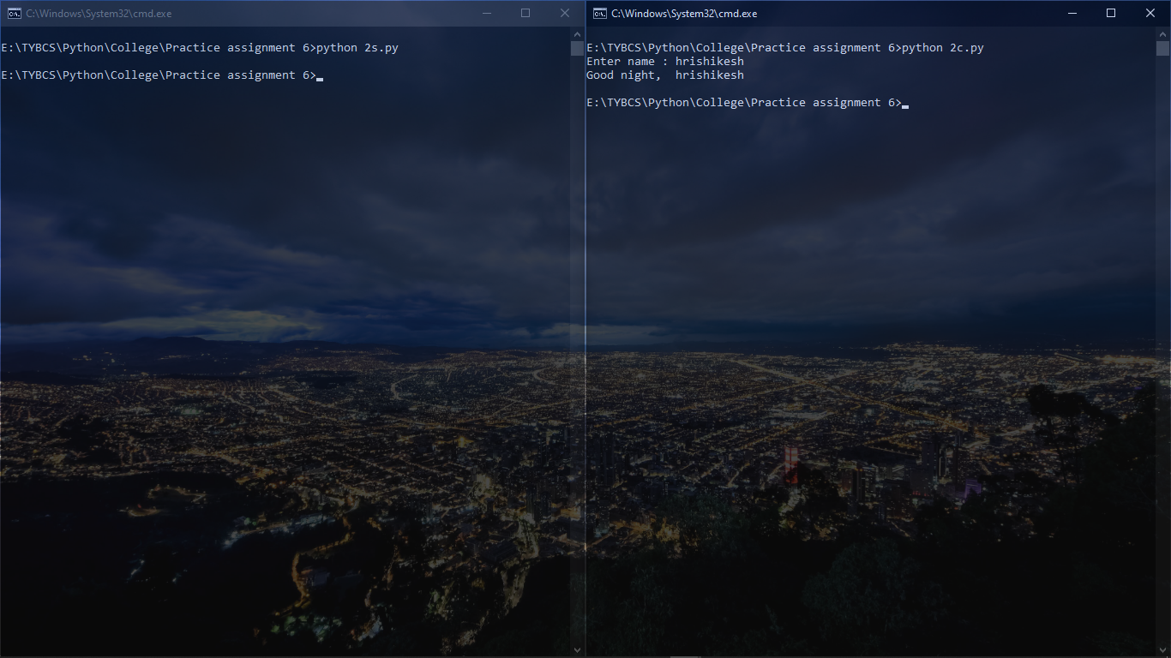

------------------------------------------------------------------------------

Q3 .

Client:

import socket

s=socket.socket()

s.connect(('127.0.0.1',666))

fname=input("Enter filename: ")

s.send(fname.encode())

data=s.recv(1024)

print(data.decode())

s.close()

Server :

import socket

ss=socket.socket()

ss.bind(('',666))

ss.listen()

client,addr=ss.accept()

fname=client.recv(1024)

fname=fname.decode()

try:

    f=open(fname,'r')

    data=f.read()

    client.send(data.encode())

    f.close()

except FileNotFoundError:

    print("Cannot find file!!")

finally:

    client.close()

Output :

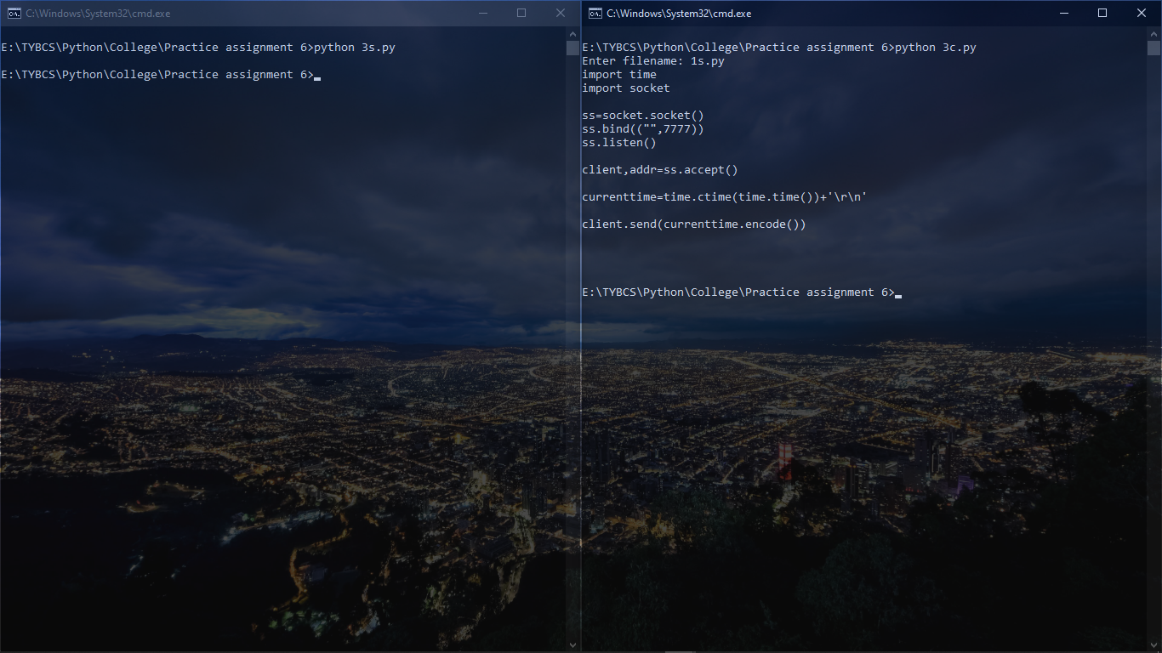

------------------------------------------------------------------------------

Q4

.

Client:

import socket

s=socket.socket()

s.connect(('127.0.0.1',777))

data=s.recv(1024)

print("Server: ",data.decode())

while True:

    msg=input('Client:')

    s.send(msg.encode())

    msg1=s.recv(1024)

    print("Server: ",msg1.decode())

    if msg1.decode()=='bye':

        break

s.close()

Server :

import socket

ss=socket.socket()

ss.bind(('',777))

ss.listen()

client,addr=ss.accept()

msg="Start a conversation"

client.send(msg.encode())

while True:

    data=client.recv(1024)

    print("Client: ",data.decode())

    msg=input("Server: ")

    client.send(msg.encode())

    if data.decode()=='bye':

        break

client.close()

Output :

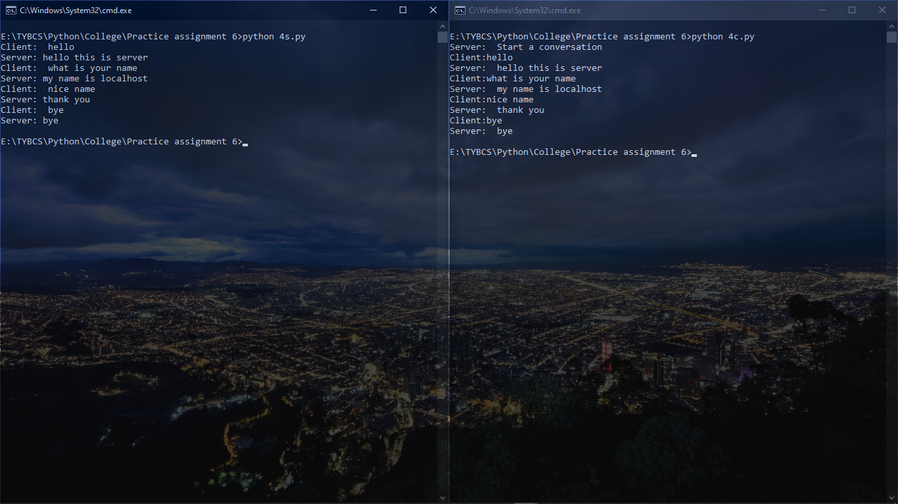

------------------------------------------------------------------------------

Q5 .

Client:

import pickle

import socket

s = socket.socket()

hostname = socket.gethostname()

portno = 50000

s.connect((hostname, portno))

std1 = s.recv(1024)

std2 = pickle.loads(std1)

print(std2)

s.close()

Server :

import socket

import pickle

s=socket.socket()

hostname=socket.gethostname()

portno=50000

s.bind((hostname,portno))

s.listen(5)

print('server is waiting...')

while True:

    conn,addr=s.accept()

    print("Connection from: " + str(addr))

    class student:

        def __init__(self,fnm,lnm,rno):

            self.fname=fnm

            self.lname=lnm

            self.rollno=rno

        def display(self):

            print("First name: ",self.fname)

            print("Last name: ",self.lname)

            print("Roll no: ",self.rollno)

    fnm=input("Enter first name:")

    lnm=input("Enter last name:")

    rno=input("Enter roll no:")

    s1=student(fnm,lnm,rno)

    std_data={"First name":fnm,"Last name":lnm,"Roll no":rno}

    std=pickle.dumps(std_data)

    conn.send(bytes(std))

    conn.close()

    break

s.close()

Output :



